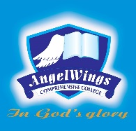

|  |  |
| --- | --- |
| **ANGELWINGS COMPREHENSIVE COLLEGE, MAROKO, PW, KUBWA, ABUJA** | |
| **SECOND TERM MIDTERM EXAMINATION 2024/2025 ACADEMIC SESSION** | |
| **SUBJECT: English Language** | **CLASS: GRADE ONE** |

1. _________ is called the light of the body (a) Hand (b) Mouth (c) Eyes